**Supporting Information**

**Hedin et al., 2019**

**Critical Metal Recovery Potential of Appalachian Acid Mine Drainage Treatment Solids**

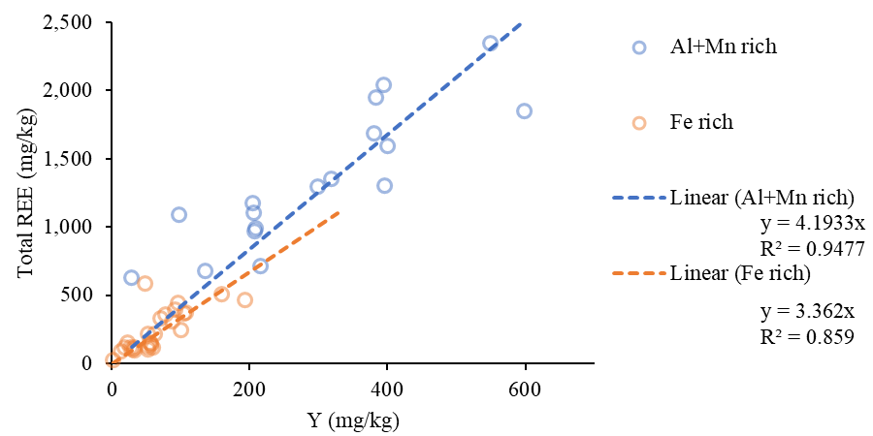

Figure S1. Linear regression between Y and total REE concentrations for Al- and Mn-rich samples (>10% Al+Mn) and Fe-rich samples (>10% Fe and <10% Al+Mn).

Figure S2. (Top) Histogram of clean energy critical REE (Y, Nd, Dy, Eu, and Tb) concentrations. Bin width is 50 mg/kg. (Bottom) Histogram of the percentage of total REE as clean energy critical REE. Bin width is 2.5%

Figure S3. U and Th concentrations in Appalachian AMD treatment solids. Red line is median, box limits are 25th and 75th percentiles, whiskers are the most extreme data points not considered outliers, and red crosses are outliers.

Figure S4. AMD treatment solids content and Co concentrations for 87 samples from across northern Appalachia.

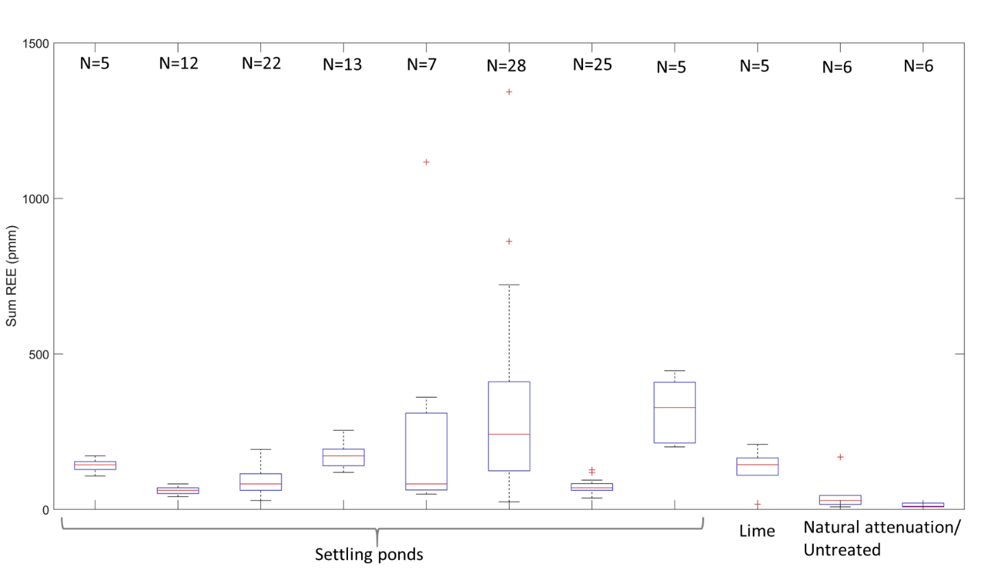

Figure S5. Variance in total REE concentrations at sites from which at least 4 treatment solid samples were collected. Red line is median, box limits are 25th and 75th percentiles, whiskers are most extreme data points not considered outliers, and red crosses are outliers.

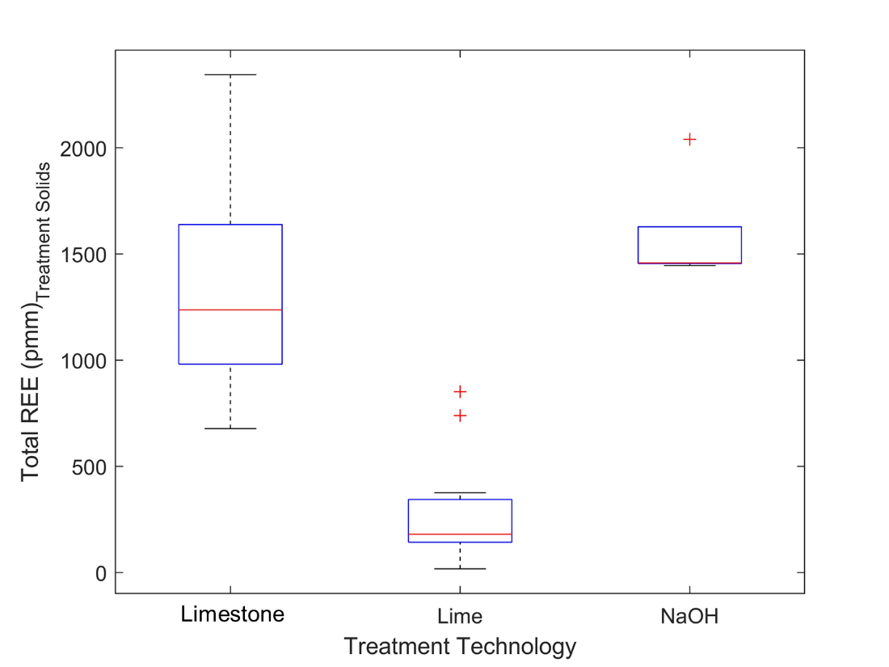

Figure S6. Total REE concentrations of technologies used to treat low pH (<5) AMD. Red line is median, box limits are 25th and 75th percentiles, whiskers are the most extreme data points not considered outliers, and red crosses are outliers.

|  |
| --- |
| **Table S1. Equations used to calculate missing REE concentrations. REE values used in the calculations are NASC normalized (Gromet et al., 1984).** |
| Pr = La * 0.33 + Nd * 0.66 |
| Gd = Sm * 0.33 + Tb * 0.66 |
| Dy = Tb * 0.80 + Yb * 0.20 |
| Ho = Tb * 0.60 + Yb * 0.40 |
| Er = Tb * 0.40 + Yb * 0.60 |
| Tm = Tb * 0.20 + Yb * 0.80 |

|  |  |  |  |  |  |  |  |  |  |  |  |  |  |  |  |  |  |  |  |  |  |  |  |
| --- | --- | --- | --- | --- | --- | --- | --- | --- | --- | --- | --- | --- | --- | --- | --- | --- | --- | --- | --- | --- | --- | --- | --- |
| **Table S2. REE concentrations for 13 Appalachian AMD treatment solids with all REE measured. * indicates REE calculated using the equations in Table S1. Calculated REE concentrations are maximum 2.2% of total REE concentrations. Total REE* concentrations are between 99.16% and 99.94% of total REE concentrations. The maximum variation between measured and calculated REE is 24% and 30 ppm. Average (±one standard deviation) differences are 7% (±6%) and 3.15 ppm (±5.07 ppm).** | | | | | | | | | | | | | | | | | | | | | | | |
| **Sample** | **Y** | **La** | **Ce** | **Pr** | **Pr\*** | **Nd** | **Sm** | **Eu** | **Gd** | **Gd\*** | **Tb** | **Dy** | **Dy\*** | **Ho** | **Ho\*** | **Er** | **Er\*** | **Tm** | **Tm\*** | **Yb** | **Lu** | **Total REE** | **Total REE\*** |
|  | **ppm** | **ppm** | **ppm** | **ppm** | **ppm** | **ppm** | **ppm** | **ppm** | **ppm** | **ppm** | **ppm** | **ppm** | **ppm** | **ppm** | **ppm** | **ppm** | **ppm** | **ppm** | **ppm** | **ppm** | **ppm** | **ppm** | **ppm** |
| **1** | 599.0 | 113.0 | 291.0 | 54.8 | 53.0 | 262.0 | 86.3 | 23.0 | 123.0 | 109.9 | 19.6 | 118.0 | 122.6 | 22.2 | 21.6 | 62.2 | 66.4 | 9.0 | 9.3 | 57.2 | 9.0 | 1,849 | 1,843 |
| **2** | 550.0 | 211.0 | 587.0 | 77.9 | 79.6 | 373.0 | 109.0 | 29.5 | 154.0 | 123.6 | 21.2 | 113.0 | 122.8 | 20.8 | 19.8 | 51.7 | 54.6 | 6.2 | 6.7 | 34.5 | 5.0 | 2,344 | 2,327 |
| **3** | 396.0 | 143.0 | 274.0 | 41.5 | 41.9 | 181.0 | 44.9 | 11.9 | 62.7 | 59.3 | 10.7 | 62.0 | 63.9 | 12.6 | 10.7 | 33.0 | 30.9 | 4.1 | 4.0 | 22.7 | 3.1 | 1,303 | 1,298 |
| **4** | 395.0 | 230.0 | 602.0 | 78.2 | 76.0 | 342.0 | 88.6 | 21.8 | 104.0 | 89.2 | 14.6 | 77.9 | 85.8 | 14.1 | 14.1 | 35.9 | 39.7 | 4.5 | 5.0 | 27.1 | 3.9 | 2,040 | 2,035 |
| **5** | 392.0 | 147.0 | 283.0 | 42.8 | 42.9 | 185.0 | 46.0 | 12.1 | 64.6 | 60.1 | 10.8 | 62.9 | 64.5 | 12.8 | 10.8 | 33.5 | 31.3 | 4.2 | 4.1 | 23.1 | 3.2 | 1,323 | 1,316 |
| **6** | 383.0 | 183.0 | 597.0 | 69.4 | 65.9 | 305.0 | 87.5 | 21.4 | 98.1 | 91.5 | 15.2 | 85.5 | 92.1 | 16.2 | 15.7 | 43.6 | 46.3 | 6.0 | 6.2 | 36.1 | 5.3 | 1,952 | 1,951 |
| **7** | 381.0 | 142.0 | 431.0 | 56.0 | 56.2 | 267.0 | 82.9 | 22.1 | 111.0 | 93.1 | 15.9 | 85.6 | 92.8 | 15.2 | 15.1 | 38.5 | 42.2 | 4.9 | 5.2 | 27.9 | 4.0 | 1,685 | 1,678 |
| **8** | 319.0 | 147.0 | 369.0 | 44.0 | 45.6 | 201.0 | 53.3 | 14.3 | 76.6 | 61.9 | 10.7 | 56.7 | 61.8 | 10.6 | 9.9 | 26.2 | 27.1 | 3.1 | 3.3 | 16.8 | 2.4 | 1,351 | 1,343 |
| **9** | 298.0 | 123.0 | 359.0 | 42.2 | 42.6 | 195.0 | 55.7 | 14.9 | 78.6 | 64.3 | 11.1 | 58.8 | 64.2 | 10.9 | 10.3 | 27.5 | 28.4 | 3.3 | 3.5 | 17.8 | 2.5 | 1,298 | 1,290 |
| **10** | 206.0 | 86.9 | 288.0 | 46.8 | 44.2 | 222.0 | 65.5 | 15.5 | 69.7 | 59.2 | 9.2 | 47.1 | 53.1 | 7.9 | 8.5 | 19.2 | 23.3 | 2.4 | 2.8 | 14.4 | 2.1 | 1,103 | 1,101 |
| **11** | 88.0 | 15.5 | 52.7 | 8.2 | 8.3 | 41.8 | 15.7 | 4.5 | 26.2 | 24.0 | 4.5 | 25.8 | 26.8 | 4.8 | 4.5 | 12.2 | 13.0 | 1.6 | 1.7 | 9.5 | 1.3 | 312 | 312 |
| **12** | 23.0 | 6.0 | 16.2 | 2.5 | 2.7 | 13.3 | 4.7 | 1.2 | 6.5 | 5.3 | 0.9 | 5.2 | 5.3 | 0.9 | 0.9 | 2.2 | 2.4 | 0.3 | 0.3 | 1.6 | 0.3 | 85 | 84 |
| **13** | 2.0 | 4.4 | 8.8 | 1.0 | 1.0 | 4.1 | 1.1 | 0.2 | 0.8 | 0.8 | 0.1 | 0.7 | 0.7 | 0.1 | 0.1 | 0.4 | 0.4 | 0.1 | 0.1 | 0.4 | 0.1 | 24 | 24 |

|  |  |  |
| --- | --- | --- |
| **Table S3. Appalachian AMD treatment solid samples and analyses included in this database.** | | |
| **REE concentrations above detection limits** | **Number of samples** | **Analysis** |
| Total REE | 13 | Correlate total REE with Y |
| (Y + all lanthanides) |
| INAA analysis | 35 | Calculate missing REE via table S1 and correlate with Y |
| (Y, La, Ce, Nd, Sm, Eu, Tb, Yb, Lu) |
| Partial REE | 45 | Estimate total REE using Y |
| (>1 REE, <9 REE) |
| Y only | 170 | Estimate total REE using Y |
| All REE below detect | 18 | Unused |

**Table S4.** All solids and water data included in this study. See attached .csv file.

**References**

Gromet, L.P., Dymek, R.F., Haskin, L.A., Korotev, R.L., 1984. The “North American shale composite”: Its compilation, major and trace element characteristics. Geochemica et Cosmochimica Acta 48, 2469-2482.