Northern Appalachia CANARY Coverage — Draft
Mathews/Arnold 3rd February 2022

The Northern Appalachian coverage area of CANARY (Fig 1.) is defined by Ruppert et al.,[1] using the low-sulfur hinge line of Arkle to segment West Virginia,[2] Ohio counties were based on the coal measures within the state,[3] while New York counties were not considered. Table 1 indicates the counties selected.
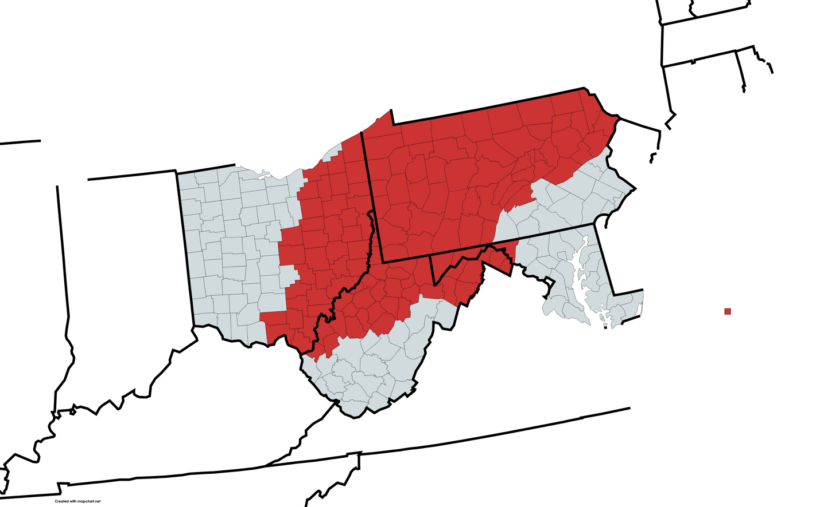
Fig. 1. Northern Appalachian coverage of PA, WV, OH, and MD counties in CANARY (source Mathews using Mapchart.net)

Table 1. Counties within the CANARY coverage area of Northern Appalachia
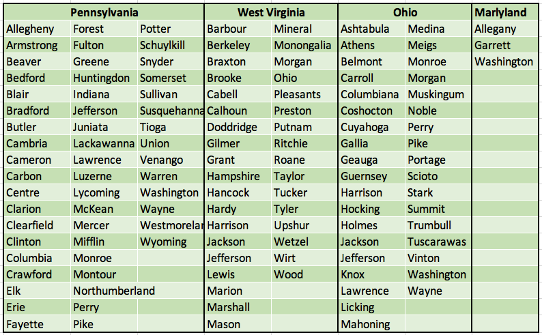

County maps are shown in Fig. 2
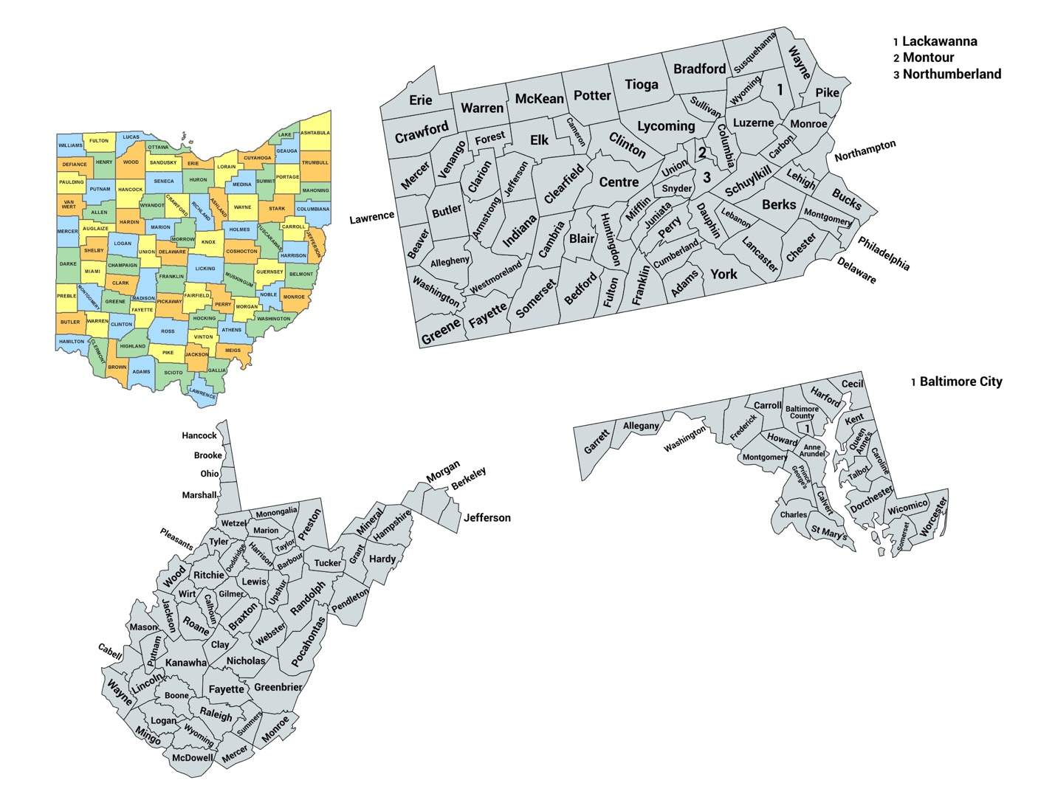

References
1 L.F. Ruppert, M.H. Trippi, S.A. Kinney, L.F. Ruppert, R.T. Ryder, Coal and Petroleum Resources in the Appalachian Basin: Index Maps of Included Studies, in: L.F. Ruppert, R.T. Rhyder (Eds.) Coal and Petroleum Resources in the Appalachian Basin: Distribution, Geologic Framework, and Geochemical Character, USGS, 2014.
2 T. Arkle, Stratigraphy of the Pennsylvania and Permian Systems of the Central Appalachians, in: G. Briggs (Ed.) Carboniferous of the Southeastern United States, Geological Society of Southeastern United States, 1974.
3 Ohio Department of Natural Resources, Coal Geology, 2022, https://ohiodnr.gov/wps/portal/gov/odnr/discover-and-learn/safety-conservation/about-ODNR/geologic-survey/energy-resources/coal-geology

